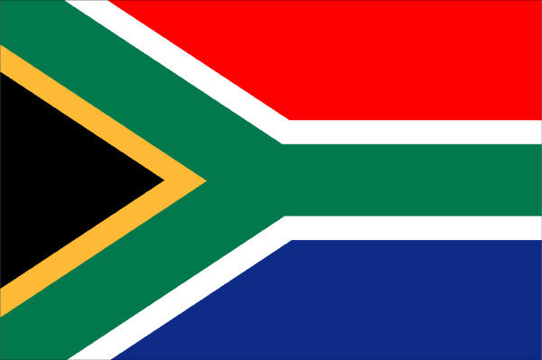

Ken Forrester Wine Tasting Dinner Thursday 28th June 2012

Canapés
Piri piri chicken liver pate on toast
Boerewors sausages on a stick
Spicy monkfish scampi

Ken Forrester Petit Chenin Blanc 2011

Smoked eel, spiced pineapple jelly, char grilled pineapple & wasabi

The FMC Chenin Blanc 2010

Duck & cherry pie, buttered spring greens

The Renegade Shiraz Grenache 2006

Lamb noisette with pancetta, lavender and tomato jus,

The Gypsy Grenache Syrah Mourvedre 2009

Honey poached pear with Roquefort cream cheese

T Noble Late Harvest Chenin Blanc 2009

