Christmas at The Second Floor, Bristol

Festive feasting is our favourite

Tis' (almost) the season for sensationally tasty Christmas fare....

This year, we’re showcasing the very finest seasonal produce, combining the rich flavours of Christmas in dishes to suit all tastes (all freshly prepared) and serving them in the relaxed atmosphere of the Second Floor Restaurant.

Whether you’re searching for the ultimate venue for a team Christmas party, Christmas dinner with friends or family, or simply celebrating the season; be sure to book now so as to not miss out on the sensational tastes at Harvey Nichols Bristol.

The Second Floor Christmas menu includes two courses for £25 or three courses for £30 and is served at lunch 12 midday – 3pm (Monday to Saturday) and 12 midday – 4pm (Sunday) and at dinner 6pm – 10pm (Tuesday to Saturday). Available until Wednesday 24 December.

If you need any assistance with your Christmas Dining bookings, from the grand corporate dinners through to the smaller, intimate gatherings, please contact the Second Floor Reception on 0117 916 8898, email reception.bristol@harveynichols.com.

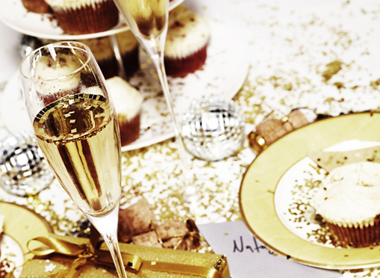

SECOND FLOOR
CHRISTMAS MENU

2 courses £25.00, 3 courses £30.00
Why not start your meal with a glass of HN Champagne 125ml 8.50 / 175ml 12.50

Celeriac velouté, seared scallop, morcilla

Potted crab, pink grapefruit and pickled fennel salad,
brown crab sticks

Roast beetroot cannelloni, goats cheese mousse, beetroot carpaccio,
citrus reduction

Home smoked venison, confit orange, coriander and honey glaze, bitter chocolate
dressing

Roast loin and slow cooked pork cheek, ham hock croquette, smoked potato purée,
cider poached apples

Roast fillet of bass, vanilla parsnips, bok choi, crisp prawn wonton, ginger beurre blanc

Pumpkin pithivier, wild mushrooms and lentils, cabernet reduction

Roast breast of guinea fowl, creamed savoy cabbage and bacon, chestnut purée,
poached cranberries, sprout tops

Harvey Nichols Christmas pudding, cider brandy sauce

Tangerine dream - jelly, sorbet, curd, dark chocolate crunch

Forme D’Ambert cheese, pears, candy walnuts, pain d’epice

Dark chocolate crème brûlée, milk sorbet, mango compôte

harveynichols.com

